

***Department of Computer Science & Engineering***

**Course Title –** Software Engineering

**Course Code –** CSE 322

**Section** - A1

Project Proposal

***Laptop Recommendation system using NLP***

**Date of Submission –** February 11, 2022

**Submitted by:**

Md. Hasibur Rahman (19101009)

Tanmoy Mazumder (19101013)

Shawan Das (19101020)

**Submitted to:**

Dr. Shah Murtaza Rashid Al Masud

Associate Professor,

University of Asia Pacific

1. Introduction

The pandemic has forced the world to go on lockdowns multiple times in the past 20 months. Each time students and a large number of office workers had to shift to their tasks from home and this created an unprecedented surge in Computer sales, especially Laptops since laptops are more mobile compared to their desktop counterparts and they come with a pre-built video calling specs.

*A. Problem Statement*

As the number of sales of laptops increased, so did the number of complaints from the users that they had been ripped off at the store for not understanding the specifications. This has become more and more common as there are multiple things to be considered while buying a laptop and an average person has very little to no idea of these specifications, let alone which specs would be the perfect choice for their needs.

This problem can be tackled by searching online for reviews, as user reviews reflect a true image of how the product really is. However, this method falls short because of one problem: there are literally thousands of reviews online about hundreds of such devices.

*B. Literature Review*

Sentiment analysis is the analysis of customer’s opinions, expressions, likes and dislikes towards products, organizations or services. These papers primarily work on this.

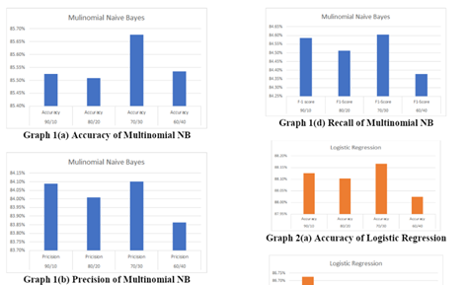**A. Product Recommendation using Sentiment Analysis of Reviews: A Random Forest Approach**

*Authors: Gayatri Khanvilkar, Prof. Deepali Vora*

Ø Tries multiple approaches

Ø Based on various products

Ø Classifies the content based on polarity

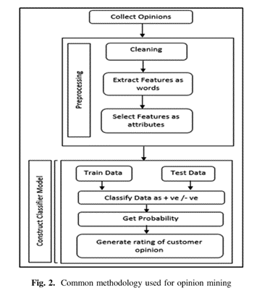

**B. Data Analysis: Opinion Mining and Sentiment Analysis of Opinionated Unstructured Data**

*Authors: Harshi Garg, Niranjan Lal*

Ø Provides a more structurally defined approach

Ø Goes deeper into the topic of sentiment analysis

Ø Discusses both approach of Machine learning and

Lexicon-based

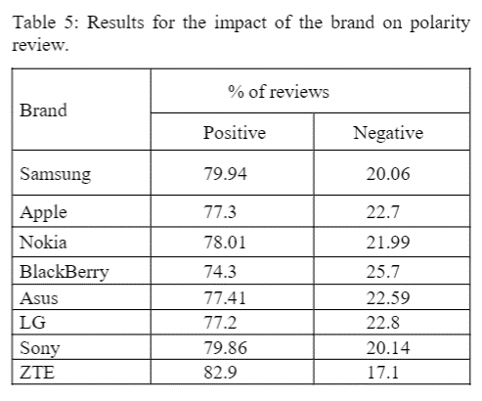

**C. Comparison of Naïve Bayes, Support Vector Machine, Decision Trees and Random Forest on Sentiment Analysis** *Authors: Márcio Guia, Rodrigo Rocha Silva, Jorge Bernardino*

Ø Works on a similar dataset: mobile phones

Ø Little outdated

Ø Viable with adjustments

**D. Tell Me What You Want: A Recommender System Based on Customer Preferences and Product Reviews**

*Author:  Josh Barua*

This is an abandoned work found on GitHub that can be used as a base for one portion of the project.

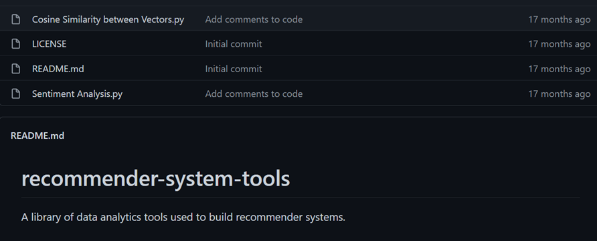

*C. Objectives*

This project tries to overcome this certain problem using NLP (Natural Language Processing) and some Machine learning algorithms used on data collected through text-mining from online review sites. The core goals of the project:

* Collecting, cleaning and analyzing user review data from the internet
* Building a system with the most suited NLP model(BERT) capable of summarizing the human-written reviews
* Building an arsenal of well-summarized reviews for a user to get the perfect suggestion from.

*D. Background Study*

From research on this particular topic online, it has been concluded that no such product / service exists that are exactly similar to the goals of this project.

# 2. Requirements:

We have two types of requirements.

i. Functional Requirements:

Here we will discuss what our software offers to the customers. On our projected website a customer needs to input their desired specifications of the laptop to see the results.

* RAM: RAM size, Specifications of the ram.
* CPU, GPU: CPU brands, GPU preference.
* Storage: Storage of the laptop.
* Weight: Weight of the laptop.

To build this website we need to acquire some hardware & software requirement:

* Software Requirement:
* VS Code
* Pycharm
* Jupyter Notebook
* Discord
* GitHub
* Hardware Requirement:
* GPU- Ryzen 7 3750H
* GPU- 8GB, RX470
* Ram- 16GB
* SSD- 240GB
* Stable Internet Connection

ii. Non-Functional Requirements:

Nonfunctional requirements judge the system how well it can execute the task given by the user and also how good the system works. Our non-functional requirements are:

* Accuracy
* Effectiveness
* 24/7 active
* Reliability

**Requirement gathering and analysis:**

In the analysis phase we gather data, analyze and validate information for the project. Define the requirements and prototype for the new system if possible. Economical and technical feasibility checked for the project in this phase.

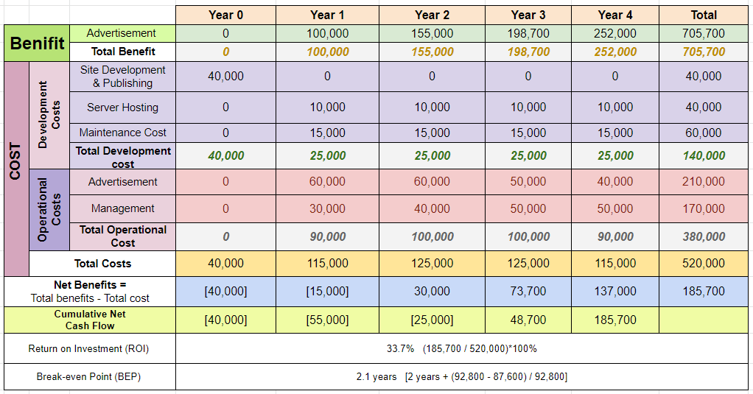

We did an economic feasibility test based on our project. We can say that our system is economically feasible to work with.

## Time Management:

|  |  |  |  |  |
| --- | --- | --- | --- | --- |
| **Week** | **Task** | **Description** | **Start Date** | **End Date** |
| 1st | A | Discussion | 18-Jan | 18-Jan |
| 2nd | B | Project Proposal | 13-Jan | 31-Jan |
| 3rd | C | Design: UML, ER-Diagram, DFD, Gantt chart | 1-Feb | 15-Feb |
| 4th | D | Project Update-1 | 16-Feb | 14-Mar |
| 5th | E | Project Update-1 | 15-Mar | 28-Mar |
| 6th | F | Project Update-1 | 29-Mar | 11-Apr |
| 7th | G | Final Project | 16-Feb | 26-Apr |

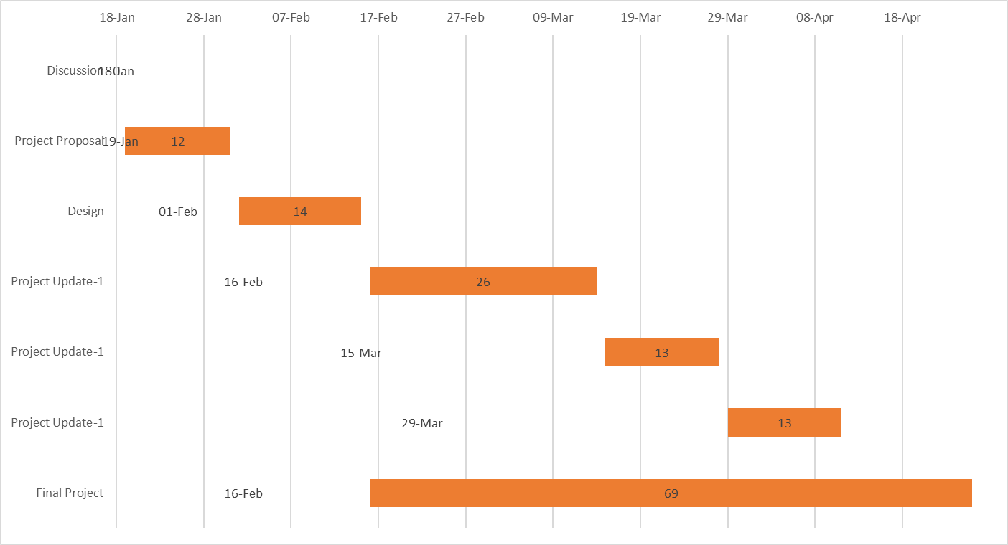**Gantt chart:**

# **3.** Methodology

We took the waterfall model for our project. Waterfall model is linear sequential design for software development, here progress flows in one direction downwards just like waterfall. Each phase must be completed before going to the next phase. Overlapping is not allowed in the waterfall model.

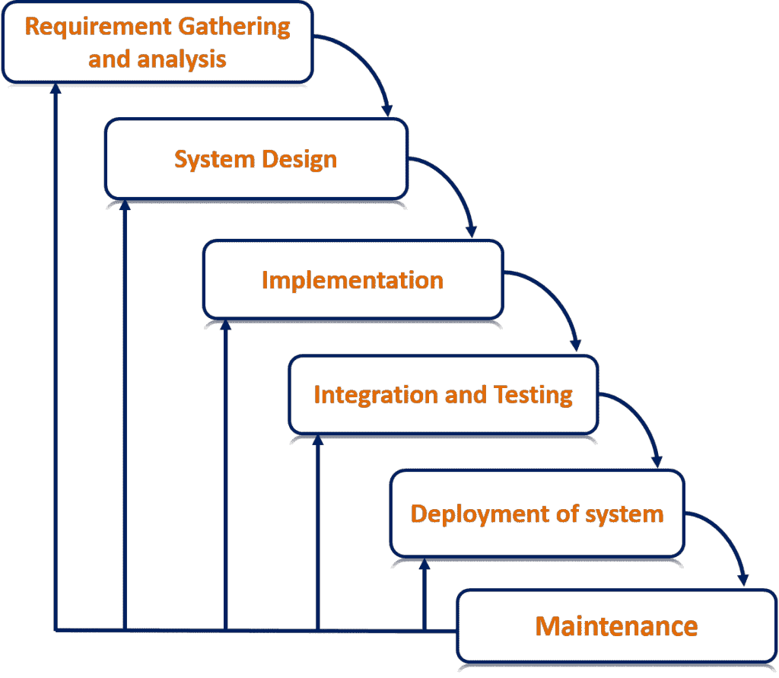

*The following points contains details about each of these stages.*

**System Design:**

In the system design phase, we design UML, ER, DFD to represent the system as whole and how it will work in future. This design will be used in the Implementation phase as documentation.

**Implementation:**

In this phase we select the platform to work with. Implement the design into source code through coding. Combine all the modules together into a training environment that detects errors and defects. It is the longest phase of system development.

**Integration and Testing:**

In this phase we integrate the system into a real-life model and test it so that we can see if the system is working properly.

**Deployment of System:**

In this phase after testing the system we can deploy the system for users.

**Maintenance:**

In this phase technical support for any bug will be provided and undergo new changes daily, monthly for any new requirements based on customer requirement.

* **Advantages:**

Some advantages of this model:

1. It is easy to understand and use.
2. It works well with small projects where requirements are well defined.
3. It defined every stage clearly.
4. Every process is well documented.

We chose this model because we know this model very well and this model is used widely for the software development process.

# 4. Complex Engineering Problem & Mapping:

* **How Ps are addressed through the project:**

|  |  |  |  |  |
| --- | --- | --- | --- | --- |
| **Ps** | **Attribute** | **How Ks are addressed through the project** | **COs** | **POs** |
| **P1** | Depth of Knowledge Requirement | Our project requires Machine learning (K2), rigorous study of existing projects(K8), surveys & reviews from users, monitoring new products (K3, K4), knowledge of web-development(K6), data collection & analysis(K5). | CO1  CO2  CO3  CO7 | PO1  PO2  PO3  PO5 |
| **P3** | Dept of Analysis Requirement | Users’ requirements, device feather's data, users demand etc. | CO4  CO7 | PO2  P12 |
| **P4** | Familiarity of Issues | We need to Analyze & implement various programming knowledge and skills to fix many issues | CO7 | PO3  PO9 |
| **P7** | Interdependence | Our project involves interdependent components such as requirement analysis, designing, back-end, front-end, software testing, dataset etc. | CO2  CO7 | PO2  PO10 |

* **How As are addressed through the project:**

| **Ps** | **Attribute** | **Ps are addressed through the project** |
| --- | --- | --- |
| **A1** | Range of Resources | Device's data is collected. Web framework is an important resource for this project. It engages diverse resources including various designing tools. |
| **A2** | Level of Interaction | Successful interaction between Web framework and NLP |
| **A5** | Familiarity | Our project deals with Internet users. |

* **How COs are addressed through the Project:**

| **Ps** | **CO Statements** | **Corresponding POS** |
| --- | --- | --- |
| **CO1** | Identifying a real-life problem that can be transmitted to an engineering or computing solution through design, development and validation. | PO4  PO10  PO12 |
| **CO2** | Identify, formulate and analyze a real world compels engineering problem based on requirement | PO2  PO3 |
| **CO3** | Design/Develop a working solution on a complex software-intensive system and verify and validate the solution using industrial state of the practice, that indicates a high-quality software-intensive system | PO1  PO5  PO11 |
| **CO4** | Use a modern/popular IDE to test complex software-intensive systems. | PO7 |
| **CO7** | Work as a team and fulfill individual responsibility | PO9 |

|  |  |  |  |
| --- | --- | --- | --- |
| **CO** | **CO Statements:** | **Appendix-1** | **Appendix-2** |
| CO1 | **Apply** the Engineering knowledge to provide a working solution on a complex engineering problem and submit a mapping. | 1 | 1/Apply |
| CO2 | **Identify, formulate, and analyze a** real-world complex engineering problem based on requirement analysis. | 2 | 1/Analyze |
| CO3 | **Design/Develop** a working solution on a complex software intensive system and verify and validate the solution using industrial state of the practice, that indicates a high-quality software-intensive system | 3 | 1/Apply |
| CO4 | **Use** a modern/popular IDE to test complex software-intensive systems. | 5 | 1/Apply |
| CO5 | **Identify** societal, health, safety, legal and cultural issues related to the project. | 6 | 1/Analyze |
| CO6 | **Practice** concepts of professional ethics, confidentiality, industrial standards. | 8 | 3/Valuing |
| CO7 | **Work** as a team and fulfill individual responsibility. | 9 | 1/Apply |
| CO8 | **Communicate** effectively through presentation and write effective reports and documentations on the project. | 10 | 1/Apply |
| CO9 | **Apply** project management principles using Version Control System, and appraise project operating cost, financial risk analysis for complex software intensive systems. | 11 | 1/Apply |
| CO10 | **Recognize** the need for, and have the preparation and ability to engage in independent and life-long learning for art of project management, distributed and collaborative software  development and risk analysis for developing complex  software-intensive systems. | 12 | 1/Apply |

|  |  |  |
| --- | --- | --- |
| **No.** | **PO** | **Differentiating Characteristic** |
| 1 | Engineering Knowledge | Breadth and depth of education and type of knowledge, both theoretical and practical |
| 2 | Problem Analysis | Complexity of analysis |
| 3 | Design/ development of solutions | Breadth and uniqueness of engineering problems i.e., the extent to which problems are original and to which solutions have previously been identified or codified |
| 4 | Investigation | Breadth and depth of investigation and experimentation |
| 5 | Modern Tool Usage | Level of understanding of the appropriateness of the tool |
| 6 | The Engineer and Society | Level of knowledge and responsibility |
| 7 | Environment and Sustainability | Type of solutions. |
| 8 | Ethics | Understanding and level of practice |
| 9 | Individual and Team work | Role in and diversity of team |
| 10 | Communication | Level of communication according to type of activities performed |
| 11 | Project Management and Finance | Level of management required for differing types of activity |
| 12 | Lifelong learning | Preparation for and depth of Continuing learning. |